Use the AP database on our server DBA120.abtech.edu to execute the following SELECT statements.

*Screen clip your query and results below each instruction**. (14 points each).**

1. Write a SELECT statement that returns all columns from the Vendors table inner-joined with all columns from the Invoices table. This should return 114 rows. Hint: You can use an asterisk (*) to select the columns from both tables.

Screen Shot 2017-06-22 at 10.38.04 AM.png

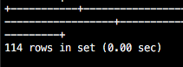

1. Write a select statement that returns these four columns:

|  |  |
| --- | --- |
| Column Name | Contains ….. |
| vendor_name | The vendor_name column from the vendors table. |
| invoice_number | The invoice_number column from the invoices table. |
| invoice_date | The invoice_date column from the invoices table. |
| balance_due | The invoice_total column minus the payment_total and credit_total columns from the invoices table. |

Use these aliases for the tables: v for vendors and I for invoices.

Return 1 row for each invoice with a non-zero balance. This should retrieve 11 rows.

Sort the result set by vendor_name in ascending order.

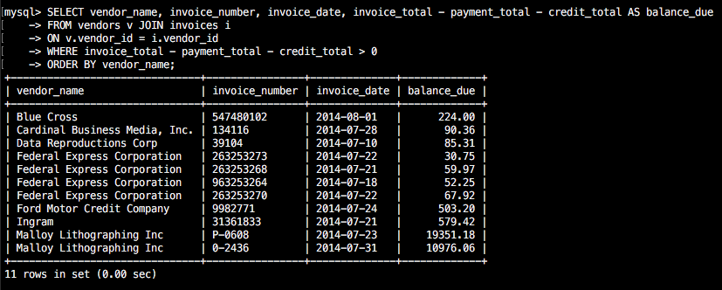

1. Write a SELECT statement that returns these three columns:

|  |  |
| --- | --- |
| Column Name | Contains ….. |
| vendor_name | The vendor_name column from the vendors table |
| default_account | The default_acount_number column from the vendors table |
| description | The account_description column from the general_ledger_acounts table |

Return one row for each vendor. This should retrieve 122 rows.

Sort the result set by account_description and then by vendor_name.

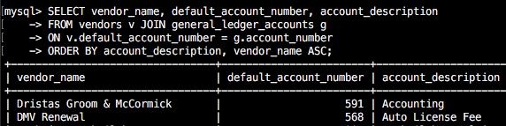

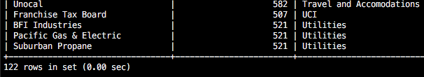

1. Write a SELECT statement that returns these fikve columns:

|  |  |
| --- | --- |
| Column Name | Contains ….. |
| vendor_name | The vendor_name column from the vendors table |
| invoice_date | The invoice_date column from the invoices table |
| invoice_number | The invoice_number column from the invoices table |
| li-sequence | The invoice_sequence column from the invoice_line_items table |
| li_amount | The line_item_amount column from te invoice_line_items table |

Use aliases for the tables. This should retrieve 118 rows.

Sort the final result set by vendor_ name, invoice_date, invoice_number, and invoice_sequence.

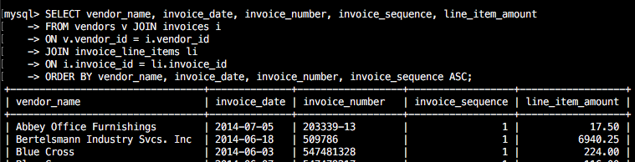

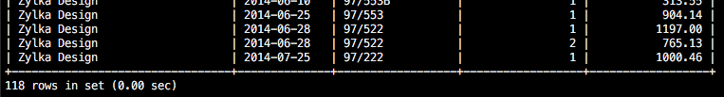

1. Write a SELECT statement that returns three columns:

|  |  |
| --- | --- |
| Column Name | Contains ….. |
| vendor_id | The vendor_id column from the vendors table. |
| vendor_name | The vendor_name column from the vendors table. |
| contact_name | A concatenation of the vendor_contact_first_name and vendor_contact_last_name columns with a space between |

Return one row for each vendor who contact has the same last name as another vendor’s contact. This should return 2 rows. Hint: Use a self-join to check that the vendor_id columns aren’t equal but the vendor_contact_last_name columns are equal.

Sort the results by vendor_contact_last_name.

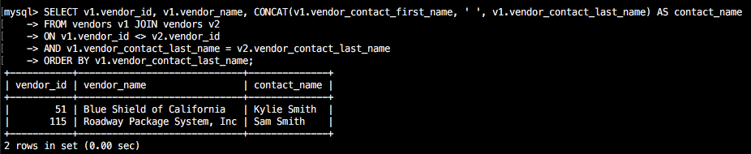

1. Write a SELECT statement that returns these three columns:

|  |  |
| --- | --- |
| Column Name | Contains ….. |
| account_number | The account_number column from the general_ledger_accounts table |
| account_description | The account_description column from the general ledger_accounts table |
| invoice_id | The invoice_id column from the invoice_line_items table |

Return one row for each account number that has never been used. This should return 54 rows. Hint: Use an outer join and only return rows where the invoice_id column contains a null value.

Remove the invoice_id columns from the SELECT clause.

Sort the final result set by the account_number column.

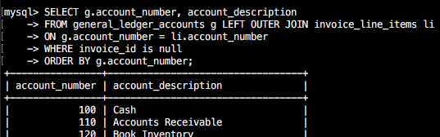

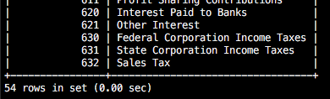

1. Use the UNION operator to generate a result set consisting of two columns from the vendors table: vendor_name and vendor_state. If the vendor is in California, the vendor_state value should be “CA”; otherwise, the vendor_state should be “Outside CA.” Sort the final result set by vendor_name.

